Practical - 4
Practical Title: JavaScript DOM Manipulation, Event Handling, and UI Interactivity

Add dynamic UI components such as collapsible FAQ, modal popup,

image/content slider, notification banner, hamburger menu, and light/dark

theme switcher using JavaScript.

Theory

1. How are DOM elements selected and modified?
document.getElementById() and updated by assigning HTML string content directly to their .innerHTML property.

2. Are event listeners attached correctly?
Yes, events are attached correctly via HTML attributes like onsubmit="validateRegistration(event)" and onload="loadCoursePageData()".

3. Is localStorage used for remembering theme choice?
No, localStorage is currently implemented only for transferring registration data across pages, not for saving theme preferences.

4. Does interactivity improve usability without breaking accessibility?
Yes, dynamic text updates enhance usability, though keeping labels and semantic HTML tags intact ensures standard accessibility is maintained.

Output
- Made a js file with functions to check the validity of input.
- Login page and other pages where inputs are needed, called js function from there to check the conditions.
- When input is invalid it do not let login and show alert box telling user that there is error in input
To View Code: https://github.com/shreyajodhani/studenthub.git

Evidence of Work (Screenshots)
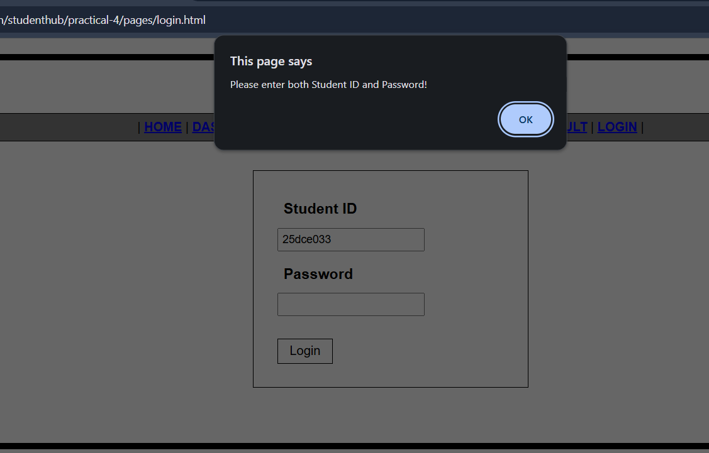Description:
Login page of website, showing alert box when password field is empty
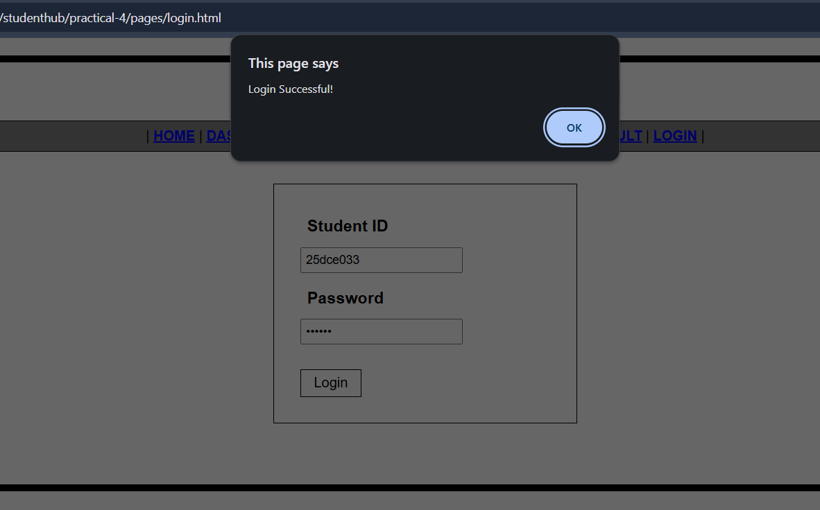

Description:
Login page of website showing successful login when ID and password are enter correctly.

GitHub Repository Link: https://github.com/shreyajodhani/studenthub.git

Challenges Faced:

To call the function from the js file properly to check if our conditions are true or not.

Learning Outcomes:
To check whether input fields are empty or input is incorrect, so before login can show an error so users change their input as per needed.

Faculty Remarks: (Keep this blank for faculty)

